**Name:** Rahul Patil

**Project:** Employee Management System

**Project Guide:** Rajiv Gupta

**Project Details:**

Employee Management System is a web application, developed to managing the information of staff data within an organization, where the Employee can Register, see list of employees, search employee by id and perform CRUD operations.

**Technologies -:**

1.MySql Database

2.Spring Boot

3.PostMan (API Tester)

## [Application Program Interface](https://www.bing.com/ck/a?!&&p=05e8ee9325be033bJmltdHM9MTY3MDE5ODQwMCZpZ3VpZD0yMDUwMWVjYS00N2ZlLTYwYzktMGYzOS0wYzljNDY5ZTYxZTEmaW5zaWQ9NTQ1NQ&ptn=3&hsh=3&fclid=20501eca-47fe-60c9-0f39-0c9c469e61e1&psq=api+full+form&u=a1aHR0cHM6Ly9ieWp1cy5jb20vZnVsbC1mb3JtL2FwaS1mdWxsLWZvcm0v&ntb=1)

**API End-Points-:**

|  |  |  |
| --- | --- | --- |
| GET | localhost:8082/project/v4/Employees | GET ALL EMPLOYESS |
| GET | localhost:8082/project/v4/Employee/{id} | GET SINGLE EMPLOYEE OF GIVEN ID IN URL |
| DELETE | localhost:8082/project/v4/Employee/{id} | DELETE SINGLE EMPLOYEE OF GIVEN ID IN URL |
| PUT | localhost:8082/project/v4/Employee/{id} | UPDATE SINGLE EMPLOYEE OF GIVEN ID IN URL |
| POST | localhost:8082/project/v4/Employee | ADD NEW EMPLOYEE |
| POST | localhost:8082/project/v4/ login | AUTHENTICATE THE EMPLOYEE |

|  |  |  |
| --- | --- | --- |
| POST | localhost:8082/Dept | ADD DEPARTMENT |
| GET | localhost:8082/DeptList | GET DEPARTMENT LIST |

ER Diagram: -

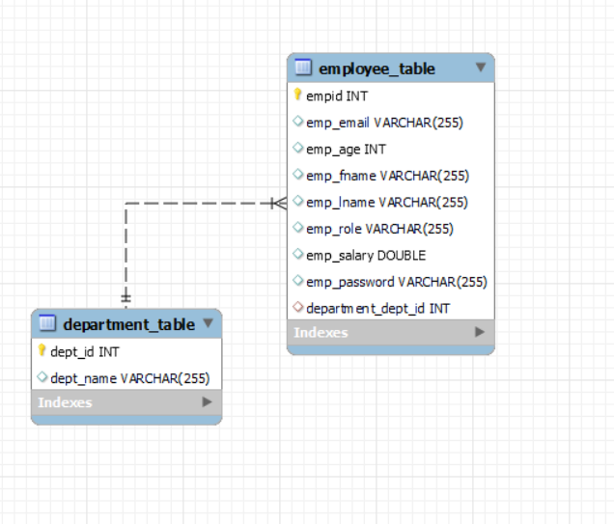

Table Structure: -

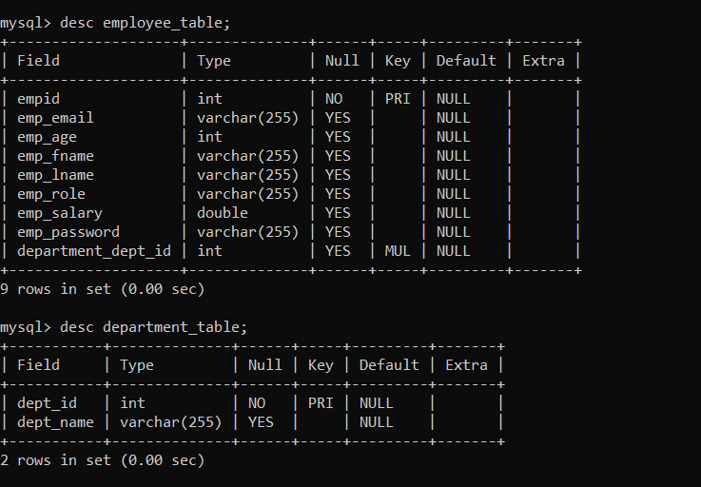

UML DIAGRAM: -

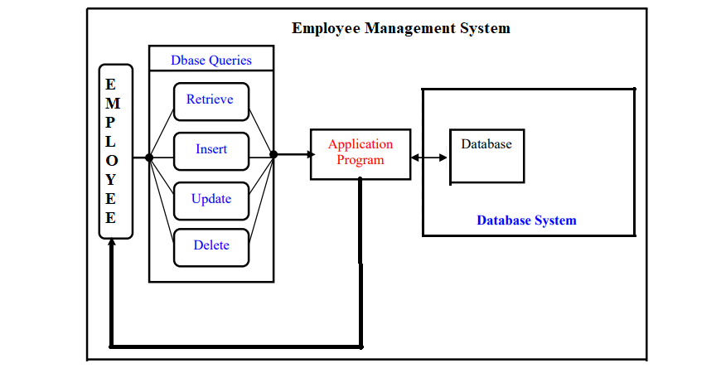

Pending Work:

1. Need to add one more table (Employee Address)
2. One Employee has many addresses. (Mapping)
3. Add Regex
4. Write Query (Find Highest Salary of Employee)
5. Find Which Department has how many employees.